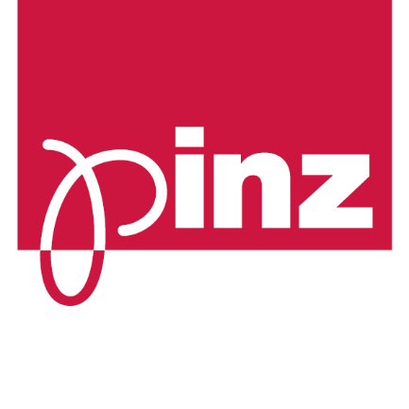

Pinz 2020 Training Registration Form

Please complete a copy of this form for each individual training participant and return to Pinz via email to Raquel raquel@pinz.com.au or Kate kateb@pinz.com.au.
Important note: Your seat will not be reserved until Pinz has received this form completed in full.
Training Date/s
Company Name
Attendee Name
Email address
Contact Phone
Company Address**
Job Title
Position/s | (tick as many as apply) | ☐ Owner | ☐ Salesperson | ☐ Installer | ☐ Administrator
Dietary Requirements
**If you are travelling from outside Metropolitan Adelaide, please complete page 2 with your flight and accommodation details

Please select the training sessions you wish to attend:

DAY 1: ALL SESSIONS ☐
OR Select Individual Sessions: (please refer to the Pinz 2020 Training Program for session start & finish times)
☐ Introduction to Pinz | ☐ Factory Tour | ☐ Pinz Indoor Blinds & Window Furnishings
☐ Pinz Printed Blinds | ☐ Motorisation & Value Adding | ☐ Pinz Outdoor Blinds & Awnings
☐ Dinner with Pinz! (see next page)

DAY 2: ALL SESSIONS ☐
OR Select Individual Sessions: (please refer to the Pinz 2019 Training Program for session start & finish times)
☐ Pinz Folding Arm Awnings & Shade Products | ☐ Side Retention Blind Systems
☐ Ordering / Sales & Marketing / Product Support

It is a safety requirement of Pinz training that all attendees wear
factory appropriate enclosed footwear to all training sessions

Pinz 2020 Training Registration Form

DAY 1 DINNER
The fun part of Pinz Training occurs on Thursday evening! We are pleased to invite all Pinz Training attendees to join us for a casual dinner and drinks on Thursday evening, from 6.30pm onwards. Details will be confirmed closer to your training dates but this will be held locally, in the western suburbs of Adelaide. We hope you can join us for what is always an enjoyable night!
For catering purposes, please give an initial indication below if you wish to join us. Please be sure to complete page 1 with any dietary requirements or considerations you may have.
☐ Yes! I would love to join Pinz for dinner | ☐ Sorry, I can’t make it on Thursday night

INTERSTATE / REGIONAL GUESTS ONLY NEED COMPLETE BELOW

Accommodation details*
Incoming flight number
Scheduled arrival time
Departing flight number
Scheduled departure time
Do you require assistance with transfers?** (if yes, please select)
☐ From airport on arrival | ☐ Return to airport on departure | ☐ To / From Pinz daily

*Pinz recommends our regional and interstate guests stay at The Lakes Resort Hotel.
When booking your accommodation at The Lakes, please be sure to mention you are visiting with Pinz to secure a discounted corporate rate.
The Lakes Resort Hotel is conveniently located only 5 minutes (<3kms) from Pinz Hendon premises, 20 minutes (12kms) from Adelaide Airport, and <15kms from the CBD.
**For those guests who choose to stay at The Lakes, Pinz are happy to arrange for your airport and daily transfers. Please advise your flight information above so we can arrange a car to meet you.
For more information, visit www.lakesresorthotel.com.au
For bookings, phone: 08 8356 4444 or email: reception@lakesresorthotel.com.au

